**HTML Headings**

**Headings:**

HTML headings are titles or subtitles that you want to display on a webpage.

The HTML Heading tags define headings in HTML document/webpage.

**Types of Headings:**

There are 6 types of Headings in HTML from <h1> to <h6> tags.

The <h1> tag defines the most important heading

The <h6> tag defines the least important heading

**Code:**

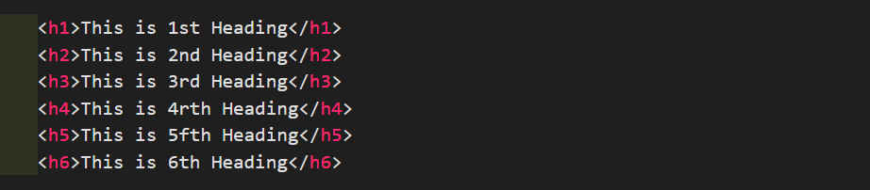

**Output:**

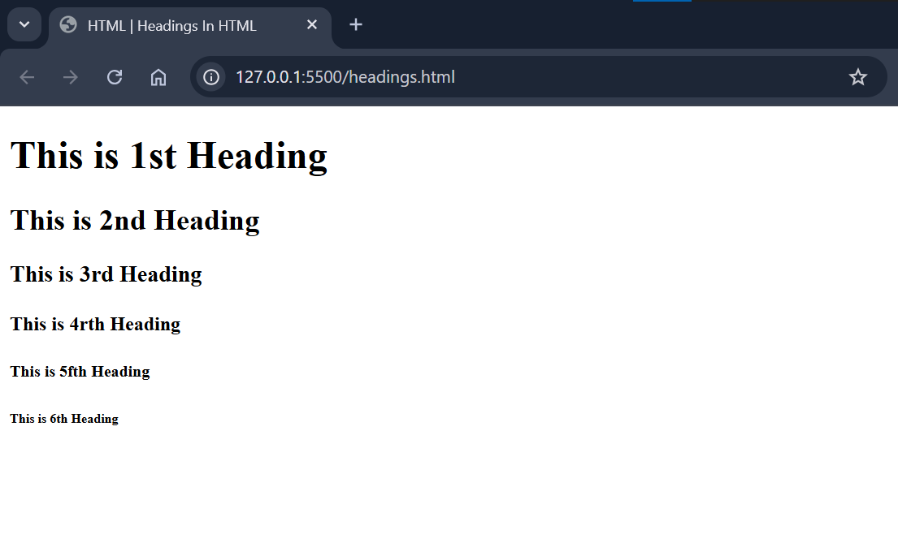

**Important Points Related to Headings:**

* Browsers automatically add some white space (a margin) before and after a heading.
* Use HTML headings for headings only. Don't use headings to make text **BIG** or **bold**.
* Search engines use the headings to index the structure and content of your web pages.
* Users often skim a page by its headings. It is important to use headings to show the document structure.
* <h1> headings should be used for main headings, followed by <h2> headings, then the less important <h3>, and so on.

**Bigger Headings:**

Each HTML heading has a default size. However, you can specify the size for any heading with the style attribute or using the CSS font-size property.

The following example is the **Default size** of Heading **<h1>** tag:

**Code:**



**Output:**

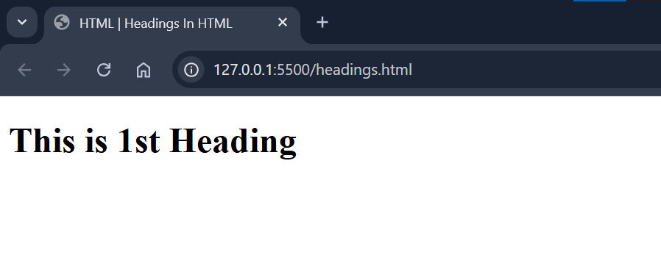

Change the size of Heading **<h1>** tag in the following example:

**Code:**



**Output:**

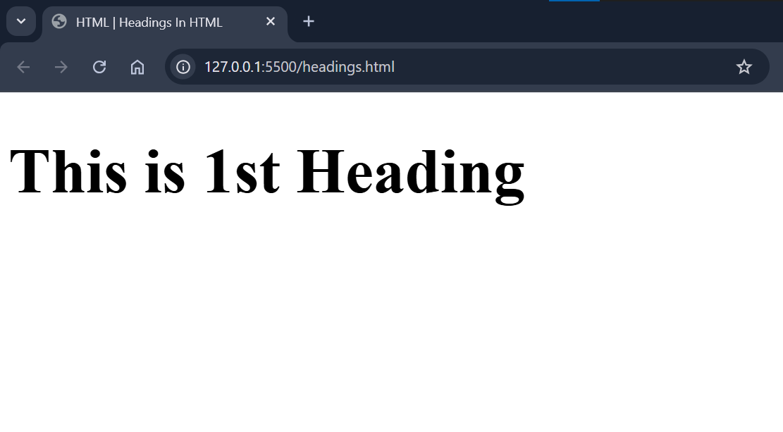

**HTML Tag Reference:**

W3Schools' tag reference contains additional information about these tags and their attributes.

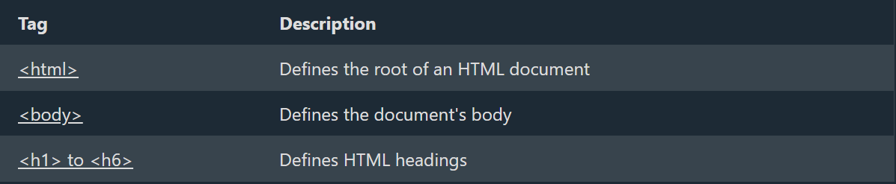

The above 2 will include in other sections.

<https://www.w3schools.com/tags/tag_html.asp>

<https://www.w3schools.com/tags/tag_hn.asp>

<https://www.w3schools.com/tags/tag_body.asp>